MKTG 3213 Principles of Marketing

Student’s Name
Institution Affiliation
Course
Tutor’s Name
Date

MKTG 3213 Principles of Marketing
Commonly abbreviated as JCP, JC Penney is a departmental store operating in the United States with its headquarters in Plano, Texas. Operating as a chain of stores, JCP, is located in over 689 locations within 49 states in the U.S and Puerto Rico. Apart from retailing conventional merchandise, JCP is also offering Sephora inside JC Penney, The Salon by Instyle, and Fine Jewelry departments. JCP stores house several leased departments equally, such as portrait studios, optical centers, and Seattle’s Best Coffee (JC Penney, 2021). The organization is currently owned by Simon and Brookfield Asset Management Incorporated after its acquisition in 2020. Equally, around the same time, the organization changed its initial CEO Jimmy Soltau to the current serving CEO, Stanley Shashoua. In contrast, its chief marketing officer is Marci Grebstein. Its website is JC Penney.com. Below is a review of the principles of marketing that JC Penney thus utilized in relation to its sale of apparels.
Points of Contact of Sale between Customer and JC Penney
Retail Stores
Company Website
Social Media Sites of the Company
Customer Service Number
Pricing Strategy
JC Penney
Item | Regular Prices | Sale Prices
Bathrobes | $95 | $45 (Every day price)
Men`s pajama bottoms | $30 | $3 (Clearance sale)
Dyson Vacuum Cleaner | $725 | $649
Rack of shorts | $14 | $7
Isotoner gloves | $40 | $21
Pricing method 1: Coupons
Coupons are tickets that customers can redeem as they purchase an item for them to obtain a financial discount. Retailers use coupons as a marketing tool and as part of their sales promotion strategy. JC Penny utilize coupons as part of their sales promotion strategy (Connor, 2013). The coupons granted by both retailers are similar and are based on online-eligible discount coupons that have promo codes that the customer can redeem.
The promo code can be added depending on whether the sale meets the criteria in the coupon. It is entered at any time during the checkout stage. JC Penney utilizes the same idea with its coupons that are also bolded and can be applied at the end of the sale.

Source: JC Penney (n.d)
Pricing method 2: Rebates
Rebates are retrospective payment refund or return that are paid to clients at a later date. Rebates are used by marketers for the purposes of offering clients with incentives to purchase products. Rebates target price-sensitive clients who would want to make most savings as they purchase a product (Stein, 2019). In the case of JC Penney the rebates only apply for very specific purchases that are redeemable in the platform. To access the rebates go to the link www.jcpenney.com/rebates and after you enter your zip-code the site will pull up a list of the most up-to-date offers within that geographical area. An example is attached.
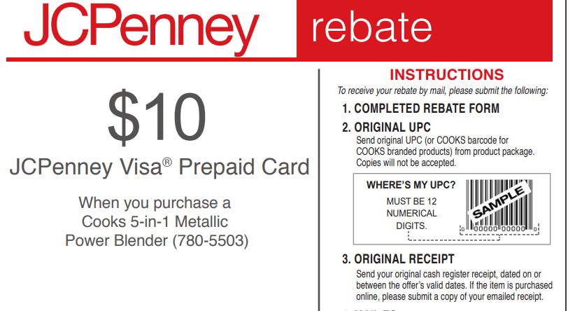
Source: JC Penney (n.d)
Pricing method 3: Rewards
JC Penney also grants its loyal clients with a reward program which allows them to earn reward points which they can then utilize to receive special member-only benefits as they shop on the stores or online at jpc.com. Rewards can be accessed by the clients debit and credit card after they register for the program. For each dollar spent, clients earn one point for the JC Penney`s sale-priced and regular-priced merchandise. Clients can sign-up using the link www.jcprewards.com.

Source: JC Penney
External and Interactive Promotions
Using web-based media as a showcasing device isn't so straightforward as it might sound. By and large, it includes planning on the strategies to send with the perspective on accumulating the designated crowd. Moreover, it similarly helps in supporting the deals, and in that productivity of associations (Dievendorf, 2020). The following is a survey of a portion of the strategies that JC Penny can use comparative with use of TikTok, and Instragram interpersonal organizations for dispersing its showcasing efforts.
Upon the closing down of vine in the year 2016, around 200 million clients leaped to Tiktok as such making up for the shortfall. The web-based media application has since become dramatically throughout the long term, a factor that has predicted it demonstrating of how famous it is becoming https://fanbooster.com/blog/tiktok-promoting/. Inferable from its notoriety, and the quantity of clients that are developing constantly, online media advertisers are wandering into this application, and along these lines utilizing on the somewhat enormous crowd in the notice of utilizing web-based media as a vehicle of publicizing. With a great development, and crowd little scaled in contrast with any semblance of Instagram, Pinterest, and Facebook there is similarly a need to institute some alert inferable from how flighty a portion of the applications can get with an illustration of how Snapchat declined.
By the by, there is some distinction that exists between Pinterest, Instagram, and TikTok borne out of the organization of content that this computerized stage produces. TikTok not at all like other online media stages produces viral computerized recordings which among other element difficulties and lip-matches up (Dievendorf, 2020). Then again, Instagram essentially depends on its clients posting short recordings and photograph, while Pinterest just take into consideration their clients to gather pieces which are identified with their substance of interest. Likewise, TikTok and Instagram draw in a crowd of people that is pertinent to the items and administrations presented by JC Penny refering to that it draws in a horde of individuals between 18 years to 25 years.
Advertisement Recommendations for JC Penney
Recommendation 1
JC Penney should strive to diversify the type of products that it sells. The retailer should do this by expanding the price list of their attires to fit that of a diverse customer base. For most of it, this should be done to fit the lower-middle-class people. This can be attributed to the fact that their sales have been on a low trend. In addition, this has been accounted from the fact that most of the customer base is mainly the affluent.
Recommendation 2
Another recommendation is for Penney to improve its user experience. The organization generally has a poor layout of its website, and this should be improved in the view of foreseeing that the user experience is better. Some of the factors to consider is the arrangement of products, as well as the layout and design of the website.
One of the factors and most important of all, in the retail world, is the need to consider the digital space. In this view, there is a need to reconsider that more customers are significantly oriented to more flexibility. Additionally, there is a higher competition rate around this space, citing that retailers are moving away from the old brick-and-mortar form of operation to an online or e-commerce base. Moreover, retailers should accord the need to consider wider demographics. This is by availing a host of products and services that suits all of them. Out of this, an organization can be more capable of bolstering its profitability. Equally, in the same manner, retailers can be able to at every one time be profitable, citing that varied demographics have varied buying capabilities at different times.
References
Connor, K. (2013). Executives beware – Are you the next Ron Johnson of JC Penney? Is your company’s low pricing IQ putting your survivability at risk? Journal of Revenue and Pricing Management, 13(1), 64-73. https://doi.org/10.1057/rpm.2013.31
Das, G. (2014). Linkages of retailer awareness, retailer association, retailer perceived quality and retailer loyalty with purchase intention: A study of Indian food retail brands. Journal of Retailing and Consumer Services, 21(3), 284-292. https://doi.org/10.1016/j.jretconser.2014.02.005
Dievendorf, A. (2020). TikTok Marketing: What Is TikTok And How Can You Market On It? fanbooster. https://fanbooster.com/blog/tiktok-marketing/
JC Penney. (2021). JC Penney. www.jcpenney.com

